Common Personality Traits
Mahmudul Alam
Colorado State University Global
20WA-CSC505-1
Wednesday, December 23, 2020

We are social beings therefore we must live in civilized way including all the people in a society. We all have characteristics and different way of being social. Some of us are nicer to people then others and some of us are not. Some of us helps people financially while others emotionally. Taking these basic principles of life to the software industry requires us to be social while developing a project. Knowing all the people work differently, we have established some common practices in software development industry, and we have created some common norms that a good developer must follow to do well in a project. According to Paul Luo, a great software engineer is perseverant, hardworking, curious, risk taking, adaptable, prideful, and focused.
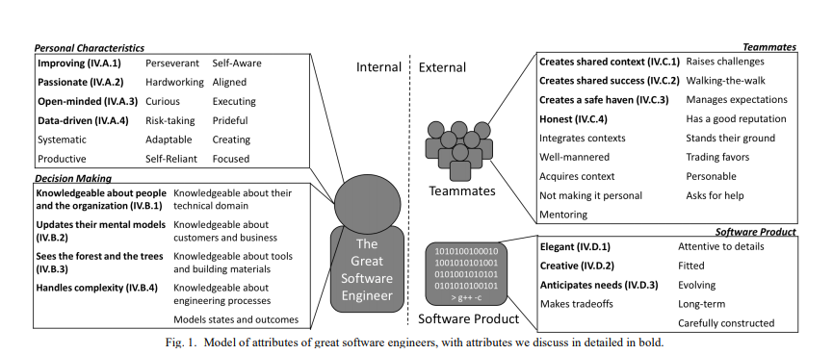
Figure 1 Paul Luo Li*+
I have seen many developers personally and I had the chance to intact with them on few projects. A great developer is independent yet well communicates with the tam. A great developer is aware of hierarchy in the development process, knowing whom to go when there is a confusion is key. Knowing how things are done around the company can also be another great quality of a great developer. Once a new developer is hired in a company, they are trained with the basics and companies standards, eventually developer works with a senior engineer and with a mentor. Once the engineer inherits al the qualities that requires to maintain companies’ standards developers adds his special touch to the whole process and creates his own version of workspace for himself. Same qualities can be applied a program where there is parent chile relation or in a class where its inheritances from the previous class. 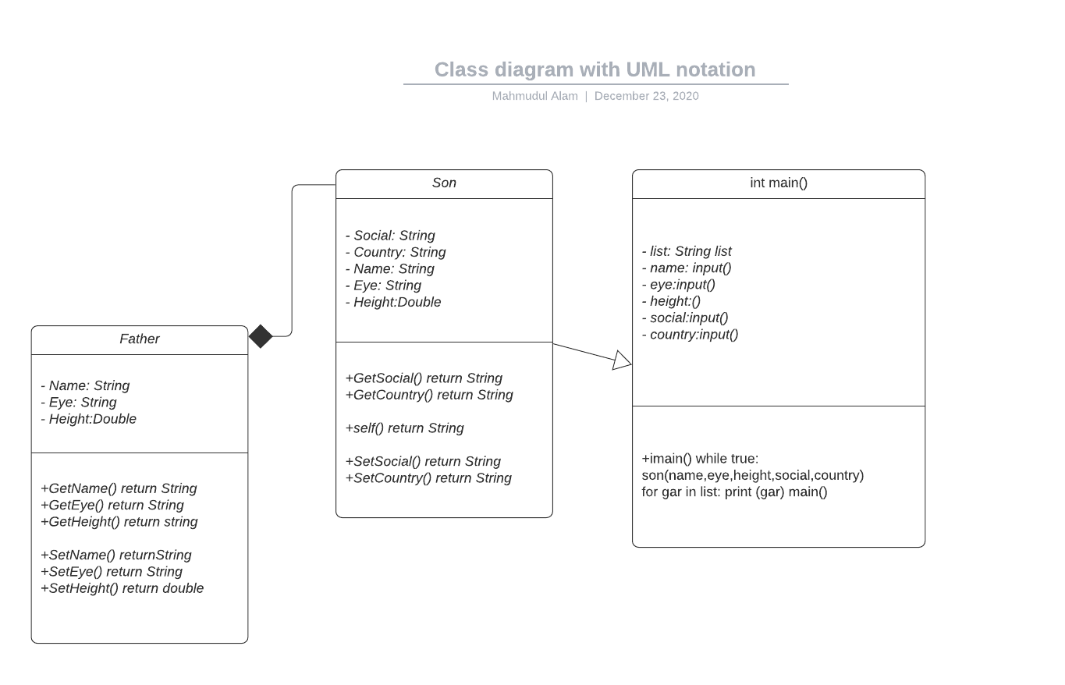
Father class has some variable and methods to get user input and for storing values. Son class added new attributes and methods to the existing class. Finally, we can access both classes just by calling son class when needed because son is inheriting fathers’ attributes and methods.

References
Paul Luo Li*+, Amy J. Ko*, Jiamin Zhu. What Makes A Great Software Engineer? Retrieved December 23, 2020, from https://faculty.washington.edu/

